NaPDI Repository Data Entry SOP: In vivo Natural Product-Drug Interaction Studies

Version 1

Creation Date: March 2017

Author: Isabelle Ragueneau

**Contents**

## 1. Background……………………………………………………………………………………………...…2

## 1.1 Scope…………………………………………………………...……………………………………2

## 1.2 Definitions……………………………………………………………………………….………..2

## 2. Creating a Study……………………………………………….…………………………………………3

## 3. Study Page…………………………………………………………………………….……………………4

## 4. Experiment…………………………………………………………………………………………………6

## 5. Experimental Conditions……………………………………………………………………………..8

## 6. Drug Administration…………………………………………………………………………………10

## 7. PK Measurements………………………………………………………………………..……………12

## 8. Pharmacodynamic and Adverse Events…………………………………………...…………14

**…. To update and complete…**

# Background

## 1.1 Scope

The purpose of this Standard Operating Procedure (SOP) is to describe how to enter pharmacokinetic-based drug interaction study results into the NaPDI repository. Natural Products (NPs) are expected to be evaluated as causative agents (*Precipitants*). The victim drugs (*Objects*) are probe substrates of known enzymes and/or transporters.

Most of the information entered in the repository will come directly from the study report. However, several text fields are provided throughout the admin site to allow the addition of relevant comments that may pertain to the experimental study design and conditions, the study results, and/or the mechanism and clinical relevance of the interaction. This additional information should be reviewed with the principal investigators during the validation process as it will be used to enrich the users experience and understanding of the clinical results.

## Definitions

**Natural Product**: Botanicals, herbal remedies, vitamins, or other dietary supplements.

**Probe Cocktail Study**: A study where a "cocktail" or set of drugs designed to "probe" or measure the activity of multiple enzymes of interest are administered in a pharmacokinetic study.

**Double-Blind Design**: An interventional study in which neither the subjects of the experiment nor the persons administering the experiment know the critical aspects of the experiment; a double-blind procedure is used to guard against both experimenter bias and placebo effects.

**Fixed-Sequence Design**: A study in which treatment is administered to participants in a fixed order.

**Parallel Study Design**: A parallel group design or independent measure design is a study design which uses unique experimental unit each experimental group, in other word no two individuals are shared between experimental groups, hence also known as parallel group design. Subjects of a treatment group receive a unique combination of independent variable values making up a treatment.

Add all relevant definitions here when they are finalized… and present alphabetically.

# Creating a Study

Use the following steps to create a new study.

## Navigate to the Admin page of the NaPDI Repository

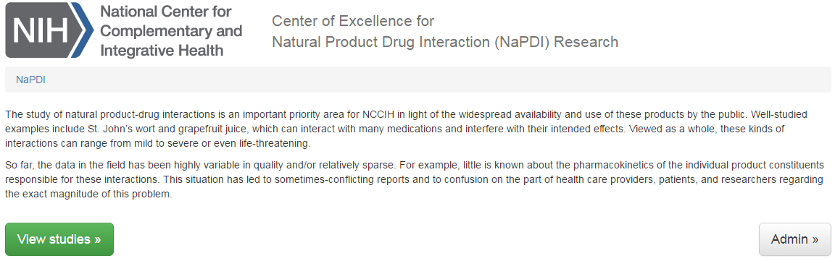

* 1. Using the admin page, click on “Studies”:

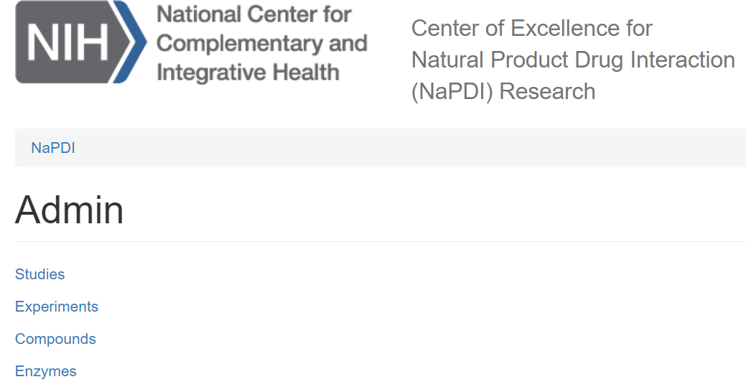

* 1. then, click on “Add new study”:

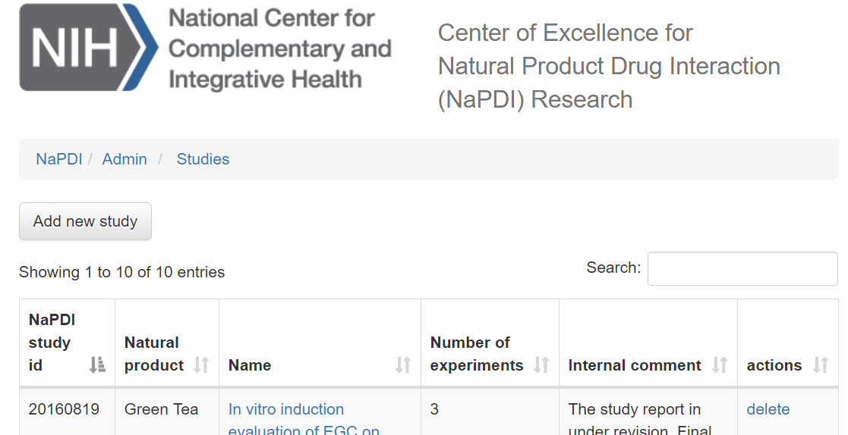

# Study Page

A study can only accept data from one Natural Product and one species. For example, *in vitro* data with Licorice *Glycyrrhiza glabra* L*.*, *Glycyrrhiza uralensis* Fish have to be reported in two different studies, one for each Licorice species.

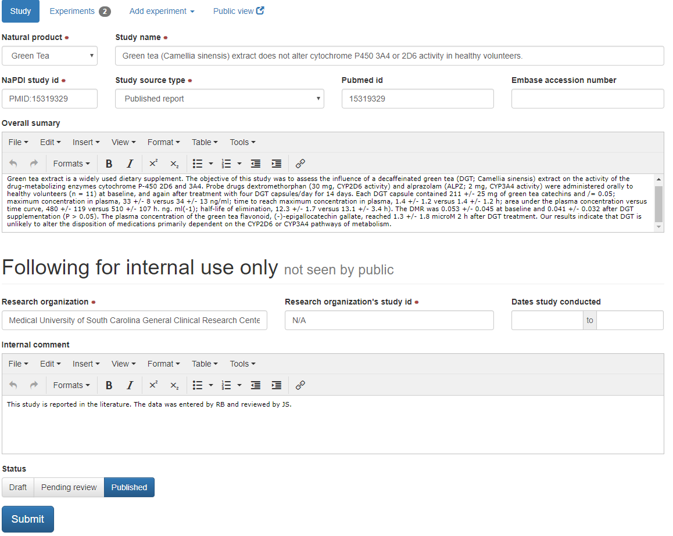

* 1. Select from the list the **Natural Product** tested in the clinical study (Select One; Required).
  2. Enter the **Study Name** in the text field (Required; as presented in the study report).

If a entries originate from a published paper, used the Pubmed ID or Embase PUI as the NaPDI Study ID (e.g., “PMID:23268924”)

* 1. Provide the **NaPDI Study ID** (Required; from Study Report).
  2. Select the **study source type** or source from which the study was obtained (required).
* Published report
* Manuscript prepared or submitted for peer-reviewed publication
  1. Unpublished data submitted through a NaPDI formIf/when study has been published, enter the **PubMed ID** and/or **Embase Accession** numbers (Optional).
  2. **Overall summary**: the summary should provide an overall conclusion (1-2 sentences) and discuss the possible mechanism(s) involved and clinical relevance of the study results (Optional).

If entries are from a published paper, copy and paste the abstract into the Overall summary box.

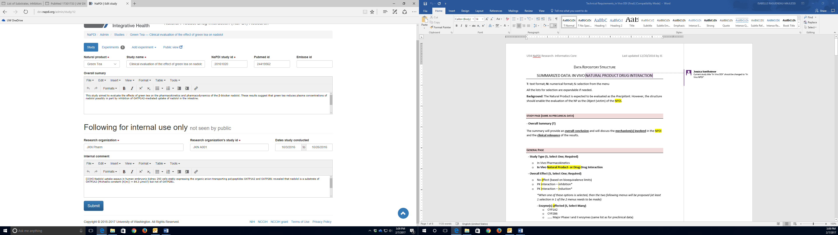

* 1. The **Following for internal use only** section is for internal notes and will not be displayed to users.
  2. Enter the **Research Organization** (where the study was performed) name (Required), study ID number (Required), and the dates the study was conducted (optional). This information should be available in the Study Report provided to the Informatics Core by the Principal Investigators. If only months are provided, select the first and last days of the month for the starting and ending date, respectively. Example: March to April, 2017 will be entered as 03/01/2017 to 04/30/2017. Note that the Research Organization Study ID may be identical to the NaPDI Study ID.
  3. Internal comment (Optional): *not sure what type of comments we had in mind here…*

Proposal: anything that could have affected the study results and needs to be internally documented

**the**

3.9 Select the status of the current study entry

* Draft – selected when the curator is in the process of entering the data or checking the data
* Pending review – selected when the study had been fully entered by the curator and needs to be reviewed and validated by a second editor
* Published – selected after validation and is ready for public display

**study.**

# Experiment

*After* a study has been created, use the following steps to add a new experiment.

* 1. Click on **add experiment**, then select **In Vivo Natural Product – Drug Interaction** from the drop-down menu.

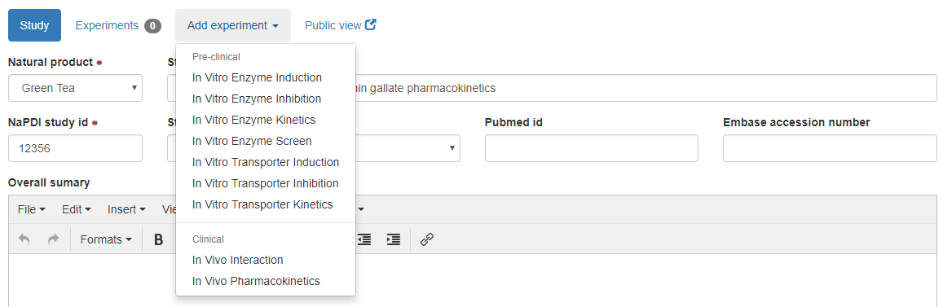

* 1. Select the **Overall Effect** based on the study findings (Select One; Required): “Increased systemic exposure” (regarding metabolism and/or transport of the *Object*), “Decreased systemic exposure”, or “No Effect” of the Natural Product on the PK of the *Object* (based on bioequivalence limits). Note that the selection needs to be consistent with the experimental study design and what is already known regarding the Natural Product ability to affect drug metabolism and/or transport (for example, a single dose of precipitant cannot induce drug metabolism…).

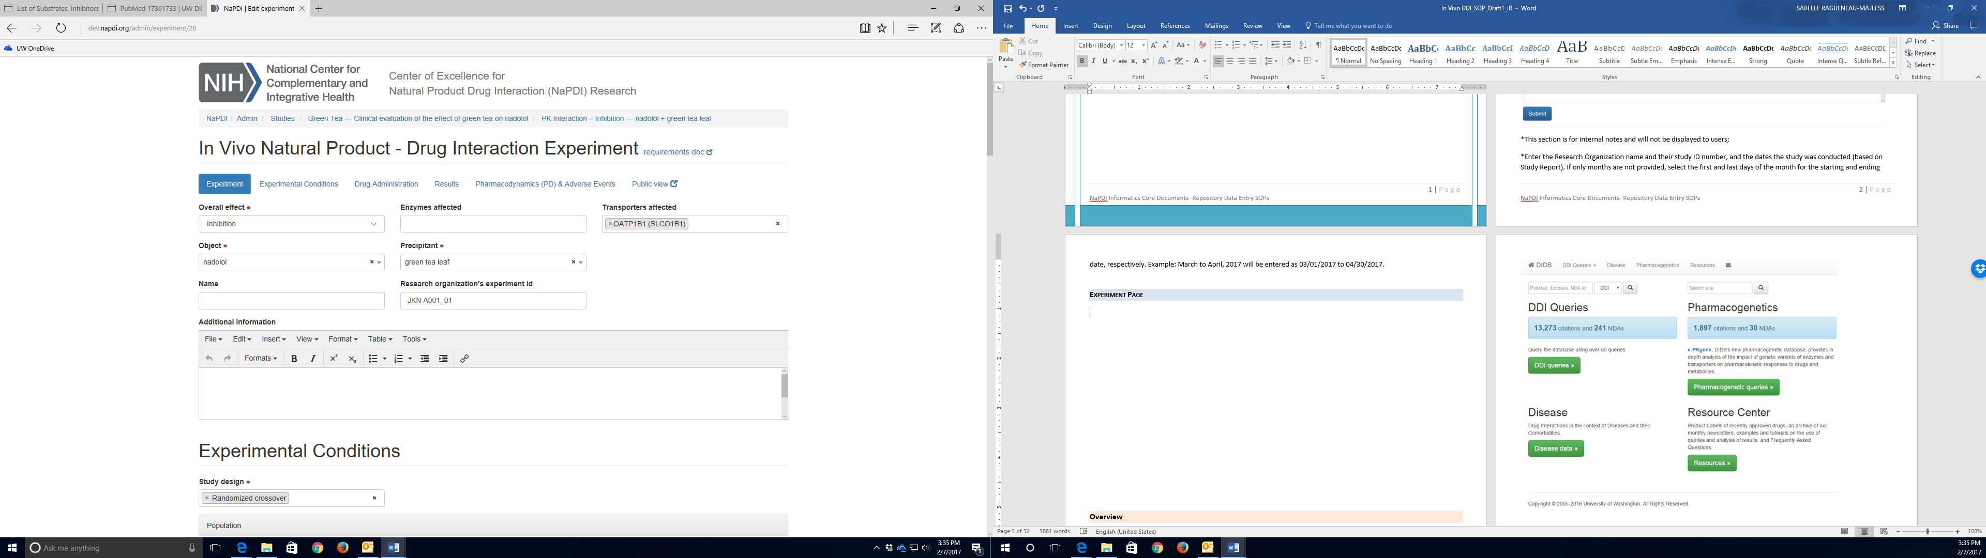

* 1. Select the **Enzyme(s)** and/or **Transporter(s)** **affected**. Multiple selections can be made to reflect complex drug interaction mechanisms (inhibition of CYP3A4, CYP2C19, and P-gp for example). This information should be consistent with the study summary (Study Page). If the exact mechanism of the interaction is unclear (which specific enzyme or transporter is affected), these fields can be left empty.
  2. Select the **Object** and **Precipitant** names from the compound lists (Select One; Required).
  3. Enter an **Experiment** **Name** if desired (for example: “*CYP3A4 inhibition Experiment*”). Note that this field is optional. Experiments names will help structuring the display of the clinical study. For example, a study could have evaluated the inhibition/induction of multiple CYPs by the Natural Product, using a cocktail approach (multiple probe substrates administered), and relating the probe substrate (Object) to a given enzyme using the experiment name will ease the presentation of the study.

Example:

Study Name (study page): “Effect of Green Tea on clinical CYP3A and CYP2C9 activities in healthy volunteers”.

Experiment 1 name: “CYP3A experiment”

Experiment 2 name: “CYP2C9 experiment”

* 1. Enter the Research **Organization Experiment ID** if available (not required);
  2. Provide **Additional information** as needed regarding the specific experiment (Optional). Comments can include details of the experiment or discussion of the mechanism of the interaction.

Example:

“The effect of Green Tea on CYP3A was evaluated using a micro dose of midazolam, a known probe substrate of the enzyme, which has been shown not to be a substrate of P-glycoprotein.”

# Experimental Conditions

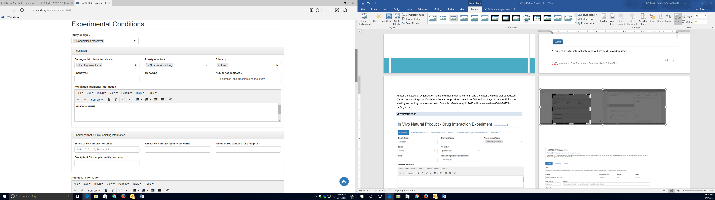

* 1. Select from the list the appropriate **Study Design** (Select Many; Required). Multiple selections can be made (example: random-crossover, double-blind, placebo-controlled). See “Section 1.2” for the definitions of terms.
* Probe cocktail study
* Double-blind
* Fixed-sequence
* Parallel
* Placebo-controlled
* Randomized crossover
  1. Select the **Demographic characteristics** of the study population (Select Many; Required):
* Females
* Healthy volunteers
* Males
* Males and females
* Patients
  1. Select the **Lifestyle Factors** relevant to the Study Population (Select Many; Optional), if available in the study report:
* Nonsmokers
* Smokers
* No alcohol drinking
* Healthy alcohol drinking
* Unhealthy alcohol drinking
* No marijuana use
* Occasional marijuana use
* Regular marijuana use
  1. Select the subjects’ **Ethnicity**, if known (Select Many; Optional). NIH Categorization (http://grants.nih.gov/grants/forms.htm)
* Not Hispanic or Latino
* Hispanic or Latino
* American Indian / Alaska Native
* Asian
* Native Hawaiian or other Pacific Islander
* Black or African American
* White
* More than one race
  1. Select the **Phenotype** of the study subjects is available (Select Many; Optional).
  2. Select the **Genotype** of the study subjects if available (Select Many; Optional).
  3. Enter the **Number of subjects** enrolled and the number of subjects who completed the study (Required).
  4. Enter any **Additional information** on the study population that was not previously described (specific ethnicity for example). This field can be left empty.
  5. Enter the details of the **PK sampling information** (optional): times of PK samples for the object -and precipitant if measured (enter ALL time points), any quality concerns, and additional information relevant to PK sampling. This information should be directly extracted from the study report. If not available, all the fields can be left empty.

When entering conditions from published literature that refer to experimental conditions described in a reference, check the reference for conditions that are not clearly stated in the article. For example, if an article states that CYP1A2 substrates and concentrations used in Vivid CYP screening assays were used as described in Cheng et al. and the authors do not describe any further details, check Cheng et al. for experimental conditions and enter those stated therein. Also, make a comment in the additional information section regarding which parameters were extracted from the reference citation (*e.g.*, Object and object concentrations tested were extracted from Cheng et al., 2017).

# Drug Administration

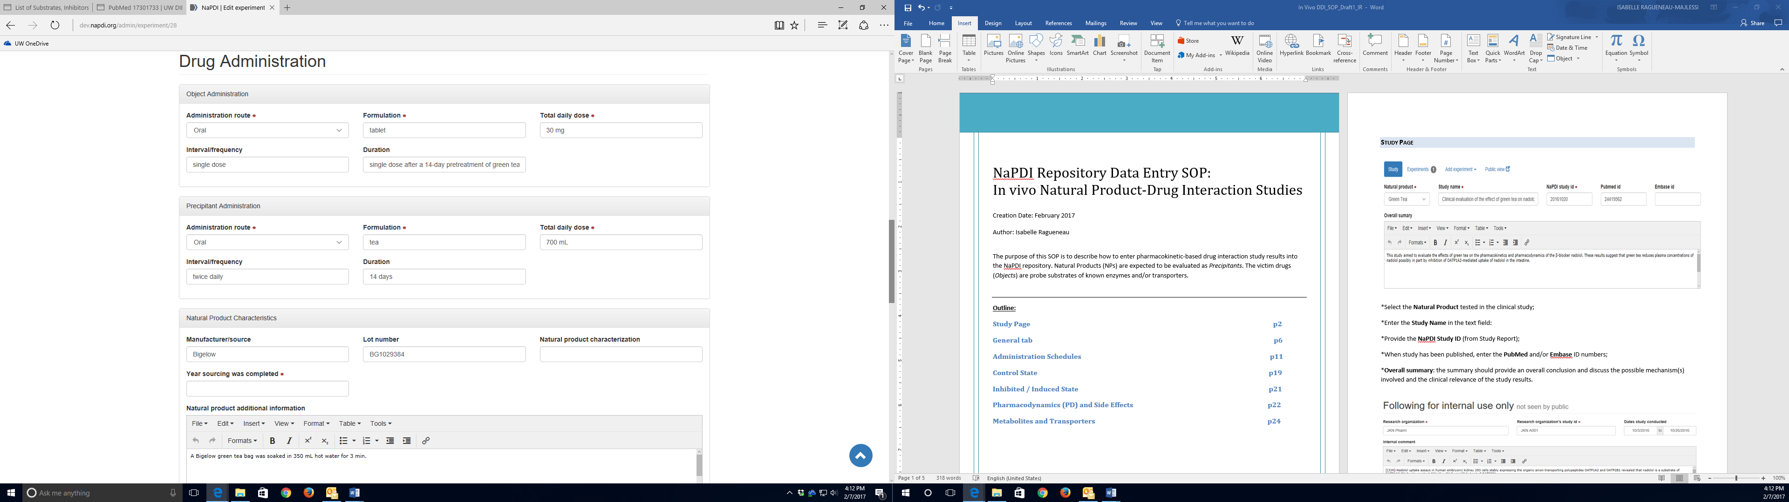

* 1. For the object AND the precipitant, enter the following information regarding **Drug Administration**:
     1. Select the **Administration route** (Select One; Required):
* Oral
* IV
* Transdermal
* IM
* Inhalation
  + 1. Enter the specific drug **Formulation** used in the study: tablet, capsule, extended/slow-release formulation, etc…, as described in the study report (Required).
    2. Enter the **Total daily dose** (“400 mg” for a 200 mg BID administration for example) (Required).
    3. Specify the **Interval** (i.e. the frequency of administration during the day): single dose, once daily, BID, TID… etc. For objects, the interval should be described the way the drug is administered when it is given alone (control phase) and when it is administered in combination with the precipitant. (Optional).
    4. Enter the **Duration** of the drug administration, and provide detailed timing between the administration of the object and the precipitant (Optional).
  1. For the Natural Product (NP), enter:
     1. **Manufacturer/Source** of the NP used in the study (Optional)
     2. **Lot Number** if available (Optional)
     3. If the NP was **characterized** by the Analytical Core (yes/no; Optional)
     4. The **Year the sourcing was completed** (Required)
     5. Any additional information on the NP used in the study (for example, how it was prepared before administration) (Optional)

# PK Measurements

* 1. Pharmacokinetic (PK) measurements of the *object* administered alone (**Control**) and with the precipitant (NP) (**Test**) will be entered. Only numeric values can be entered. PK measurements may include the parent drug, its metabolite(s), and/or enantiomers, during the control and during the inhibited/induced period. Changes in mean values (test versus control) will be computed systematically by the application. A box for statistically significant results can be checked, with p value selections:
* Check “Statistically significant” if statistically significant
* Choose P value from the list (Select One)
* < 0.05
* < 0.01
* < 0.001

PK measurements of the *precipitant* (Natural Product constituents, metabolites, and/or stereoisomers) will also likely be available in the study report and will need to be entered.

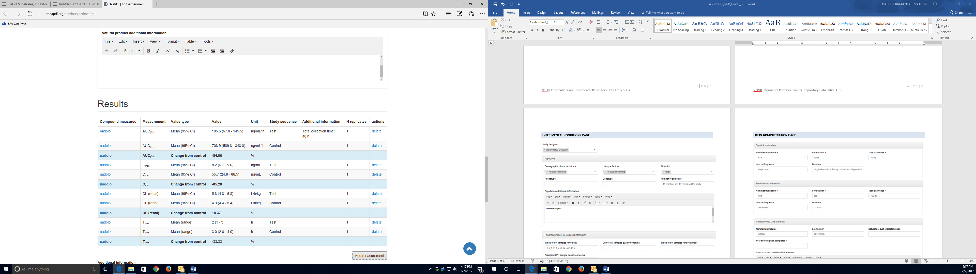

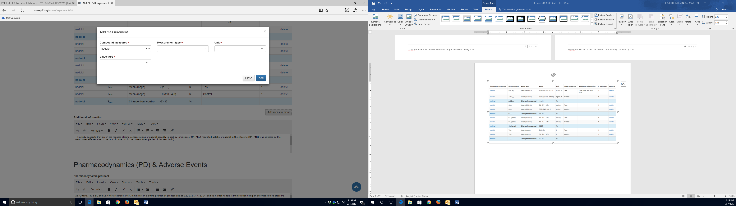

* 1. Use the **Add Measurement** function to add a new measurement in the Table of results:
     1. Select the **compound** (parent drug or metabolite) name that was measured (Select One; Required);
     2. Select a **measurement type** from the list, the associated **Unit** and the **Value Type** (Select One; Required), then **Add**.
     3. Use the **Additional Information** text box to provide any relevant information regarding the specific measurement, such as the total collection time for example.

# Pharmacodynamic & Adverse Events

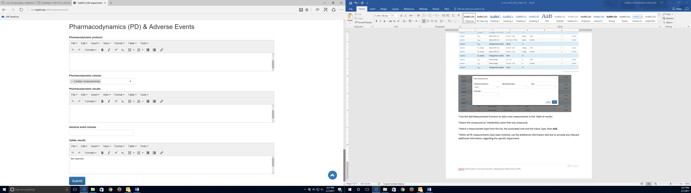

* 1. If pharmacodynamic (PD) measurements were performed in the study, provide a short summary of the **PD** **protocol**, as provided in the study report (Optional).
  2. Select a **Pharmacodynamic Class** from the list (Select Many; Optional):
* Blood cells measurement
* Blood pressure and vascular effect
* Bone mineral investigation
* Bronchopulmonary function tests
* Cardiac measurements
* Cerebrospinal fluid tests
* Clinical response to treatment
* CNS objective effects
* CNS subjective effects
* Coagulation parameters
* Endocrine investigation
* Enzymes investigation
* Gastrointestinal measurements
* Glucose monitoring
* Imaging/histopathology procedures
* Lipids analysis
* Nociceptive tests
* Protein/chemistry analyses
* Psychiatric measurements
* Receptor occupancy
* Renal excretion measurements
* Water/electrolytes measurements
  1. Summarize the main **PD results** in a few sentences.
  2. If **adverse events** (AE) have been reported by the study subjects, select all appropriate **AE classes** from the list (Select Many; Optional):
* Abnormal laboratory results
* Blood pressure/vascular disorders
* Bone and joint disorders
* Breast disorders
* Cardiac disorders
* Coagulation disorders
* Cutaneous reactions
* Ear and labyrinth disorders
* Endocrine disorders
* Gastrointestinal disorders
* General disorders/administration site conditions
* Glucose metabolism disorders
* Gynecological disorders
* Hematologic disorders
* Hepatobiliary disorders/liver injury
* Infection
* Lipids metabolism disorders
* Mouth disorders
* Muscles disorders
* Nervous system disorders
* Neurological disorders
* Nutrition and weight disorders
* Psychiatric disorders
* QT interval prolongation
* Renal and urinary disorders
* Respiratory, thoracic and mediastinal disorders
* Sexual disorders
* Sleep disorders
* Taste disturbance
* Visual disorders
  1. Provide a short summary in the “**Safety results**” text box (a few sentences). If nothing was reported, enter “No adverse events were reported by the study subjects”. If the information is not available in the Study Report, enter “Information not available”.

**View” function near the top of the page.**

* 1. Click to save the entry.
  2. After submitting the study entry, it can be viewed as it will appear to the public by clicking on the “Public View” function near the top of the page:

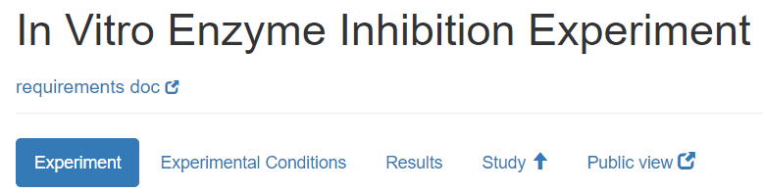

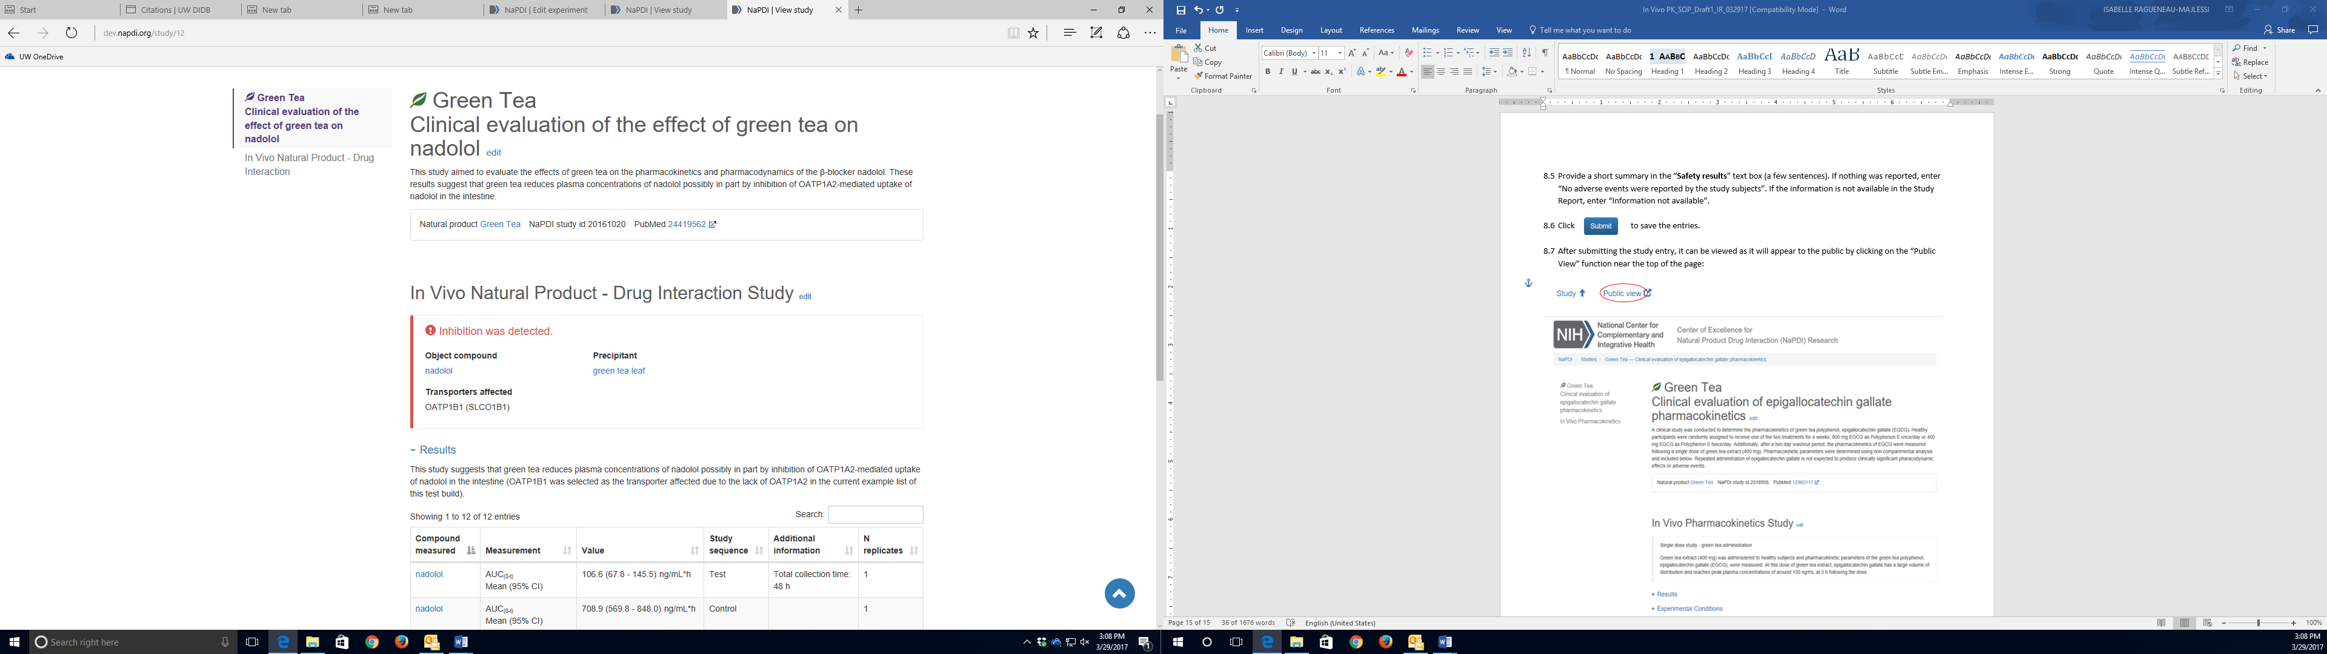

Note regarding units: For consistency use the following abbreviations for the specified units below. If a unit is not listed below, use the units specified in the Study Report.

|  |  |
| --- | --- |
| Unit | Abbreviation |
| hour(s) | h |
| minute(s) | min |
| second(s) | s |
| day(s) | day(s) |
| liter | L |
| per unit | /unit (*e.g.*, /min) |
| micro | µ |
| fold | -fold (*e.g.*, 3.2-fold) |
| exponents | ^ (*e.g.*, 10^-6) |
| less than, less than or equal to | < , ≤ |
| greater than, greater than or equal to | > , ≥ |
| plus or minus | ± |

* Use molar concentration rather than moles per liter(i.e., use µM rather than µmol/L). In the case of natural products, the use if grams per liter (i.e., µg/mL) may be necessary.
* Do not convert gram concentrations (*e.g.*, µg/mL) to molar concentrations (*e.g.*, µM), even if the molecular weight of the compound is provided.
* If the units provided for a given field are different from the units in its corresponding drop-down menu, convert the units provided in the study report to the units provided in the drop-down menu. If this is not possible (for example, µg/mL cannot be converted to µM for natural product mixtures because there is not a molecular weight available for the conversion), add the new unit to the drop-down menu.